

**December 2011**

ADVENTURE PRINCESSES

RUNNING WATERS

**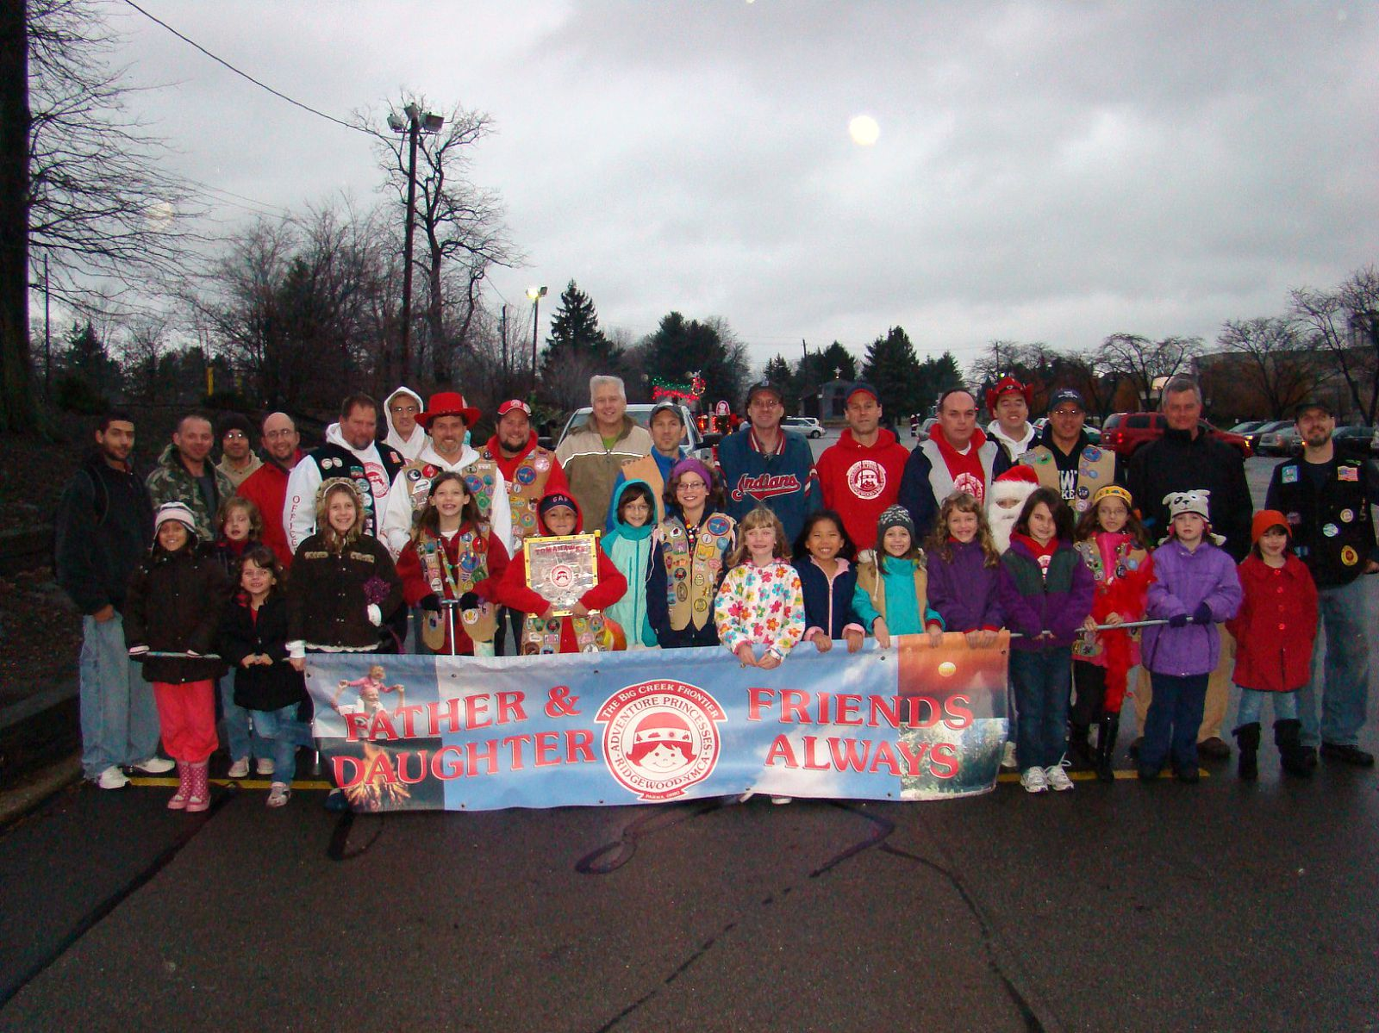**

**Neither snow nor rain nor heat nor gloom** **will keep us from marching in a Parade**MCPE03741_0000[1] Trail Boss Letter: MCTN00101_0000[1]

**Upcoming events: AP Christmas Party (12/11), Festival of Fluffs (12/16), Induction Ceremony (1/8/12)**

Yetta Hey Princess Dads and Daughters, its ***December……HAPPY HOLIDAYS!!!!!!!!!!***

**Thanks for a Wonderful Year!**

The year is almost over!!!! Rah – Rah – Ruda (Mark Ruda) will be starting as the 2012 Trail Boss after the January 8th Induction Ceremony – I will be moving to the “Elder” position.

December Frontier Meeting is coming up: We will be voting of the 2012 Officer Corps and starting registration for Winter Camp! – *first camp for the NEW SKY TERRITORY*.

***Christmas Party:***  Our annual Christmas Party will be SUNDAY, December 11th @ Tri – C West. The price of admission will be “ONE JAR” of Peanut Butter or a “Toy for Tots” toy. *Your choice of donation:* With the cost of peanut butter rising - we are helping the Parma Area hungry centers and the toys will be donated to the “Toys for Tots” Program.

***Induction Ceremony – January 8th:*** Remember NEW SKY your two sticks “Patience” and “Obedience”. The sticks will be gathered and put into your first Winter Camp Council Fire in February. *It’s an old joke – but I think our new (former) Firemaker would like some very large sticks – logs! To haul home.*

**Thank you 2011 OFFICERS! , Trail hands & Mom’s – Senior Princesses:**

Everyone did a wonderful job handling all of this year’s events! I know the work that it takes to make these events happen, the sacrifice of not being able to spend time with your daughter and the “Family Commitment” when Mom’s – Siblings take part. I would like to say THANK YOU to everyone for a terrific year.

FYI: Last week’s cover for both the “Running Waters” and The Senior Princess “Spotlight” showed the picture of our *(Former) Assistant Trail Boss In-Character “Dress-up Reunion”.*  One of the first ever gatherings of all the former “Assistant Trail Boss’s” in their ghost march costumes. Thanks guys – it was great fun and the girls enjoyed the memories.

\_\_\_\_\_\_\_\_\_\_\_\_\_\_\_\_\_\_\_\_\_\_\_\_\_\_\_\_\_\_\_\_\_\_\_\_\_\_\_\_\_\_\_\_\_\_\_\_\_\_\_\_\_\_\_\_\_\_\_\_\_\_\_\_\_\_\_\_\_\_\_\_\_\_\_\_\_\_\_\_\_\_\_\_\_

***Fourth Year Council Fire DVD’s – For Sale;***

We are selling DVD copies of the ceremony for $5.00 at the Christmas Party – Winter Fluff Raid and Induction Ceremony. They are available from me personally or from the Asst. Trail Boss at his clothing sales table.

***Fa dot and Chew!*  Greta, Marlena and Greg Noeth – 2011 Trail Boss**

**OUTPOST EVENT SIGN-UPS 3/24/2011**

|  |  |  |  |  |  |
| --- | --- | --- | --- | --- | --- |
| **EVENT** | **DATE** | **OIC** | **Outpost**  **#1** | **Outpost #2** | **Outpost** **#3** |
| Car Race | Apr 3 | **DiCola [Food] &**  **Pat Perchacs** | **SQUIRRELS** | **CHEY FLY EXPRESS** | **DIAMONDBACKS** |
| Easter Party  Food  Registration | Apr 17 | **Elbows** | **CHEY FLY EXPRESS** | **CHIPPEQUOIS** | **SUN ANGELS** |
|  |  |  |  |  |  |
| Memorial Day Parade | May 30 | **Thrasher** | ***NONE*** |  |  |
| Spring Camp  Crooked River | Jun 3 | **Noeth** | **ROCK’IN COWGIRLS** |  |  |
| Fishing Derby  Registration | Jun 12 | **Tim Organiscak & Scott Smith** | **POWHATAN** | ***ONE OUTPOST REQUIRED*** |  |
| Father’s Day Drive-In | Jun 18 | **Rick (ELBOWS) Buzinski** | ***NONE*** |  |  |
| July 4th Parade | July 4 | **Thrasher** | ***NONE*** |  |  |
| Boat Race  Food  Registration | Jul 17 | **Doug Payne & Phil Thorman** | **FIRELFIES** | **CHIPPEQUOIS** | **SUN ANGLES**  **&**  ***WILDFIRES*** |
| Putt Putt | Jul 24 | **Scott Mordaunt** | ***NONE*** |  |  |
| Breakfast in the Park  Food | Aug 27 | **Scout Mordaunt** | **TIGERLILLIES** | **POWHATAN** | **DIAMONDBACKS** |
| Car Rally  Food  Registration | Sep 25 | **Organiscak**  **Nelson**  **Tischer** | **RISING DRAGONS** | **SQUIRRELS**  **FIREFLIES** | **TOMAHAWKS**  **ROCK’N COWGIRLS** |
| Overnighter  Food  Registration | Nov 19 | **Mark Nelson &**  **Tim Organiscak** | **RISING DRAGONS &**  ***BUCKEYE BUNNIES*** | **TIGERLILLIES** | **TOMAHAWKS** |
| Christmas Party  Food  Crafts | Dec 11 | **Todd Althouse** | **NORTHERN LIGHTS** | **SANDSTORMS**  **BANDITS** | **REDHAWKS** |

|  |  |
| --- | --- |
| **APLogo** | **Ridgewood YMCA**  **Adventure Princesses**  **2011/2012 Events**  **(DD) = Dad & Daughter**  **(F) = Family**  **(AP/AG) = Adventure Programs Event**  **(MD) = Mom & Dad Only Event** |
| **The dates shown below are tentative. Always check the latest issue of the *Running Waters* or** [**www.thebigcreekfrontier.org**](http://www.thebigcreekfrontier.org) **for updated information.** | |

|  |  |  |
| --- | --- | --- |
| **January 2012** | **February 2012** | **March 2012** |
| 05: Frontier Meeting (D)  08: Induction Ceremony (F)  13: Sled-fest I (DD)  20: Sled-fest II (DD)  26: Officer Meeting (D) | 02: Frontier Meeting (D)  04: Mardi Gras (MD)  (Annual Fundraiser)  17-19: Winter Camp (DD)  23: Officer Meeting (D) | 01: Frontier Meeting (D)  11: Father/Daughter Dinner (DD)  22: Officer Meeting (D)  25: Bowling (DD) |
| **April 2012** | **May 2012** | **June 2012** |
| 01: Easter Egg Hunt/Party (F)  05: Frontier Meeting (D)  22: Car Race & Fair (F)  26: Officer Meeting (D) | 03: Frontier Meeting (D)  24: Officer Meeting (D)  28: Memorial Day Parade (DD) | 1-3: Spring Camp (DD)  07: Frontier Meeting (D)  10: Fishing Derby (DD)  16: Father’s Day (drive-in) (F)  28: Officer Meeting (D) |
| **July 2012** | **August 2012** | **September 2012** |
| 04: 4th July Parade (DD)  05: Frontier Meeting (D)  08: Putt-Putt (DD)  22: Boat Race & Picnic (F)  26: Officer Meeting (D) | 02: Frontier Meeting (D)  10: Mid-Summer Fluff Raid (DD)  18: Breakfast in the Park (DD)  19: Royalton Home Days Parade (DD)  23: Officer Meeting (D) | 06: Frontier Meeting (D)  09: Recruiting Rally (AP/AG)  16: Recruiting Rally (AP/AG)  27: Officer Meeting (D)  30: Car Rally (F) |
| **October 2011** | **November 2011** | **December 2011** |
| 01: Buffalo Overnighter (AP/AG)  06: Frontier Meeting (D)  7-9: Fall Camp I (DD)  14-16: Fall Camp II (DD)  14: Ghost March Tour – Sky (DD)  27: Officer Meeting (D) | 03: Frontier Meeting (D)  12: Overnighter (DD)  13: New Member Skate (F)  16: Officer Meeting (D)  18-19: Kalahari (F)  27: North Royalton Christmas Parade (DD) | 01: Frontier Meeting (D)  11: Christmas Party (F)  16: Festival of Fluffs (DD)  22: Officer Meeting (D) |



**RISING DRAGONS**

Question - Do Rising Dragons need sleep? Answer - YES! As was discovered at the overnighter. Next time, everyone bring a small ziplock of chlorine (but don't go through customs). Not sure if any dragons made it to family skate. We were pretty whipped. While some of us slipped and slid away at Kalahari, most were prepping their walking shoes in anticipation for the NR parade.   
  
And now without further delay, and in the spirit of Thanksgiving, I present to you, in no particular order, the **TOP-10 Things Rising Dragons A Thankful For...**  
  
# 10) The AP Program - Simply Stupendous!  
# 9) NEVER - having to be subjected to Ruda in a skirt - AGAIN  
# 8) Screaming girls on the Camp Cheerful swing.  
# 7) The Rising Dragon Outpost - Genuinely great people  
# 6) Coffee - Requirement at overnighters & camps  
# 5) The Northern Lights Castle  
# 4) Officers - Way to keep things going!  
# 3) No moms, no rules at camps = Major FUN!  
# 2) Bacon - Mmmmmmm  
# 1) Friends Always - No explanation needed  
  
Dragon Breath - Out 'til December

**TOMAHAWKS**

Yetta Hey!!!

The Tomahawks attended the overnighter and turn out from all outposts new and old was great. The girls played basketball til it was time to swim and some stayed in for hours. The food was endless and the movies ran all night into the early morning hours. We had the coats for kids bin out and collected 11 coats. Thank you to those who donated. The next evening we attended the princess skate and had a wonderful time with the girls, but of course it wouldn’t be skating without falling at least once. Christmas and the joy of the season is just around the corner and we look forward to seeing all of you at the christmas party.

friends always -The Tomahawks

**WILDFIRES**

The Girls had a great time at the Overnighter. That water was cold.

A few of us made it to Kalahari – another great time.

Happy Holidays from the WILDFIRES.

**FIREFLIES**

Yetta Hey fellow Princesses,

The **Mighty Fireflies** have enjoyed our first year in the organization. We have met many fine dads, daughters and families! The Overnighter was a blast and we had fun running around the new venue. Didn't think our little sweethearts could stay up so long, but @ 4am they were still playing, running and creating lasting memories with each other. We are looking forward to the upcoming Parade, Christmas Party and Induction Ceremony. We would like to welcome in our newest Sky members to the AP family. We want to extend a heartfelt thank you to all the current officers for the past 12 months of memorable and adventure filled events. Without your dedication and behind the scene efforts we would not have had such a great fun-filled year. We look forward to another strong year from our outpost and look forward to providing even more leadership while promoting the AP program. We would like to thank all the members of the organization for making our 1st year a memorable one. We'd like to bid a fond and bittersweet farewell to the outgoing Sky Territory, your territory set great examples for us to follow. You showed us how to have fun, build bonds, and play pranks on one another in a way that promotes tom foolery and the spirit of the organization. We will do our best to uphold those traditions and make a few new ones as well. Lastly, we would like to wish everyone a Happy Thanksgiving and a Blessed Holiday Season.

Friends Always! The Mighty Fireflies.

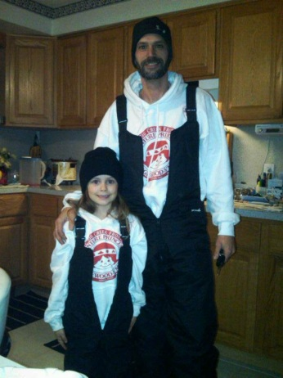

Mark and Ashley Ruda

Fire Territory Scouts

*SKY TERRITORY*



The past four years were really fun, but there was a few times I cried . The memories we made were unforgettable . I had fun learning how to shoot a gun and bow & arrows  I loved riding horses . I don”t want to leave . I am definitely  not GOING tell you that my Dad & I didn't argue . At the first camp I was scared but I would not do it any different . I really  really am going to miss the fun . just to tell you I was crying so so so mush at the last council fire . IM NOT SPOILING THE LAST CAMP YOU HAVE TO GO TO EXPERIENCE THE FUN . Written by: Holly Thorne of **The Northern Lights**. Friends Always

Yetta Hey! The **Mighty Sandstorm Bandits** had a FUN time at the Swim Overnighter. We had an Outpost Lazer Tag Party on a Friday night. The dads & daughters played 2 games to work off all the Pizza & Cupcakes we ate. This is our last Outpost/Tribe report. The last 4 years have been a BLAST! The Adventure Princesses is a GREAT organization and we are so THANKFULL to be a part of it. It has been a pleasure to be the Outpost Scout for the last 3 years. I'd like to THANK  Marlena & Greg, Sarah & Ron, Megan & Darrin, Julia & Bob, Jenna & John, Sammy & Dave, Megan & Craig, Anne & Rob, Kayla & Tim for an AWESOME 4 years. To Summer, this past 4 years have been very special spending time together at all the Camps, Buffalo/Niargra Falls trips and all the GREAT events. I will always cherish the memories. Friends Always

Contrary to popular belief, **The Diamondbacks** are VERY much still an active and functioning outpost. Apparently we used invisible ink for our last 2 months reports or this is sabotage by the rest of the Sky Territory to hold down arguably, the strongest outpost.  Anyway...to catch you up, the DBacks worked and had a great time at the Breakfast in the Park.  We especially loved running the bike hike and officiating the kickball tournament - wait, what?  The Car Rally was once again a great day even though our participation was a little below our norm.  Probably the most fun we had this year was creating and performing our first and last Ghost March skit.  Even though it took the place of our beloved Mess Hall, we found it to be quite "Thrilling" and it will go down as one of the best times we had at a camp. Speaking of that, our 4th year camp was bittersweet. It made us think back to all the great times we've had over the years and times that created a lot of laughs sprinkled in with a few tears knowing it is all over soon. We put away our torches for the last time and focused on the last couple events of the year beginning with the Overnighter. A new venue gave us some uncertainty but did not take away from a great time had by all who attended. Some of us were fortunate enough to welcome in younger sisters and attend an event together as Princesses and not just family members. It was a great way of "passing the proverbial torch" to the next Sky members. Most of us managed to make it until after 3:30AM and the longer drive didn't bother any of the dads. We're looking forward to the upcoming parades, Christmas Party and lastly, the "Induction Ceremony" where we'll officially say goodbye and leave our mark on the Ridgewood AP program.  We'd collectively like to thank all the dads, daughters and families whom we've had the chance to become friends with over the years. We'd also like to thank all the officers (including our own Mr. Ezinski, Mr. Hollo, Mr. Pierce and Mr. Bentley) who devoted countless hours to make this one of the best organizations to be a part of - a tip of the red hats to you all!  In closing, it has been a real joy for us to get to know all of you and develop friendships over the years.  We're proud to say that with some departures, additions and very little bravado, we upheld integrity and maintained dignity by selectively dominating for four years - even earning an Outpost of the Year designation in 2010 - and we remained the strongest outpost in the Sky and are proud of the legacy we're leaving.  Like the twinkle in our dad's eyes, we will forever be the brightest in the Sky from 2008-2011.  Yetta Hey and Friends Always!

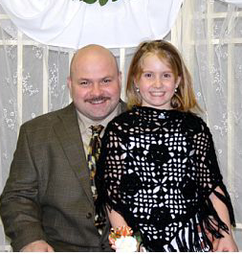

**Thank you, Tim and Hailey Organiscak,   
Sky Territory Scout**

**Forest Territory Scout:**

NO Report this Month – Look for a combined report next month

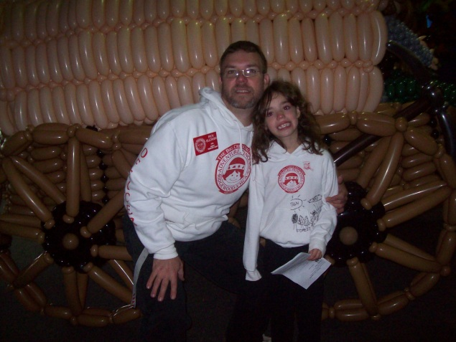

**Your Forest Scout 2011**

**Rick AKA (ELBOWS) and MIA**

MCj04382050000[1]

**SUN TERRITORY REPORT:**

**The Mighty RedHawks** had a FUN time at the Swim Overnighter. We're all looking forward to the Christmas Party & Winter Fluff Raid. Happy Birthday to ***Noelle Blaha*** on December 2 & ***Karlie Messer*** on December 9. Merry Christmas. Friends Always.

**The Chey-Fli Express** enjoyed the overnighter in Avon. Looking forward to the North Royalton Parade. Can’t wait for the Winter Fluff raid and the Christmas party.

**The** **Sun** **Angels** have been staying up late in Avon. We can't wait for the winter fluff fest. Thanks to all the officers of 2011 that made this past year fun for all of us. Good luck to those who have won the elections of 2012

**The** **Mighty** **Powhatan’s** had a good time at the overnighter. Getting ready for the winter fluff raid. Looking forward to NR Christmas Parade as well as the Christmas Party. Thanks to all the helpers/officers putting together another awesome Christmas Party. We are excited about the incoming new officers and Induction ceremony.

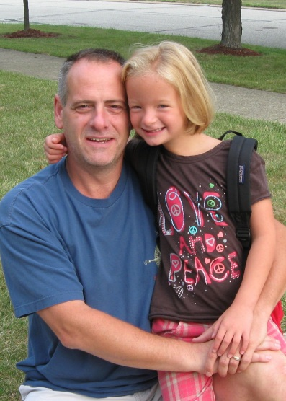

**Thanks**

**Scott N Maddee**

**Friends Always**

****



**Adventure Princesses**

**Mexican**

**Christmas Party!**

**Feliz Navidad!!!**

**Date: Sunday, December 11th, 2011**

**Time: 12:30-4:30pm**

**Place: Tri-C West**

**Parking: Park in rear lot D and use rear entrance**

**Admission: Jar of Peanut Butter or a New Toy**

***Donations benefit “Parma Area Hunger Centers” and “Toys for Tots”***

**Christmas Fun for the Whole Family**

**At the Biggest Event of the Year!**

**Baking Contest (2 categories – best taste and best decorated)**

*Note: Please do something Mexican themed and you must indicate category when you enter*

**Food, Entertainment, Games, Crafts, Santa Pictures**

**And a Good Time for ALL**



C:\Users\talthouse.BEACONSOFTCO.000\AppData\Local\Microsoft\Windows\Temporary Internet Files\Content.IE5\16R4NSU5\MC900432427[1].wmf

|  |  |
| --- | --- |
| 2011 Festival of Fluffs | |
|  |  |
| **What:** | Festival of Fluffs  Your big chance to do a great deal of fluffing with your outpost and maybe even sing a few songs along the way. |
|  |  |
| **When:** | Friday, December 16, 2011 |
|  |  |
| **Start Time:** | Any time between 6:30 pm and 8:30 pm |
|  |  |
| **Start Location:** | Tim Organiscak  8960 Tiffany Dr.  North Royalton, 44133 |
|  |  |
| **Notes:** | * Your outpost will want to plan “Fluffing Song\*” * You will need a bag to collect your fluffs * A sharp mind and a strong stomach are always very handy to bring along |
|  |  |
| **OIC:** | Roger Bundy – 216-375-3679 |
|  |  |

A “Fluffing Song” is an old song with new words about fluffing   
or Adventure Princesses

**The Big Creek Frontier would like to welcome the New Sky Territory and say goodbye to the Outgoing Sky Territory**

*Wear your Princess vests and headdresses*

***Sunday, January 8th 2012 Where: Valley Forge***

***Starts promptly at 1 pm. High School Auditorium***

***MC900351188[1]New Sky Territory members: Bring 2 sticks, one marked***

***“PATIENCE” and one marked “OBEDIENCE”.***

***Bring Mom and Dad, bring Grandma and Grandpa!***

***Fire, Sun, and Forest will receive their 2nd, 3rd, and 4th year patches.***

***New Sky will receive their headbands and YMCA patches***

***2012 Officers will be inducted too!***

***Come see the slide show and some Great performances!!!!!***

***Please bring some goodies to shareMC900232549[1]***

**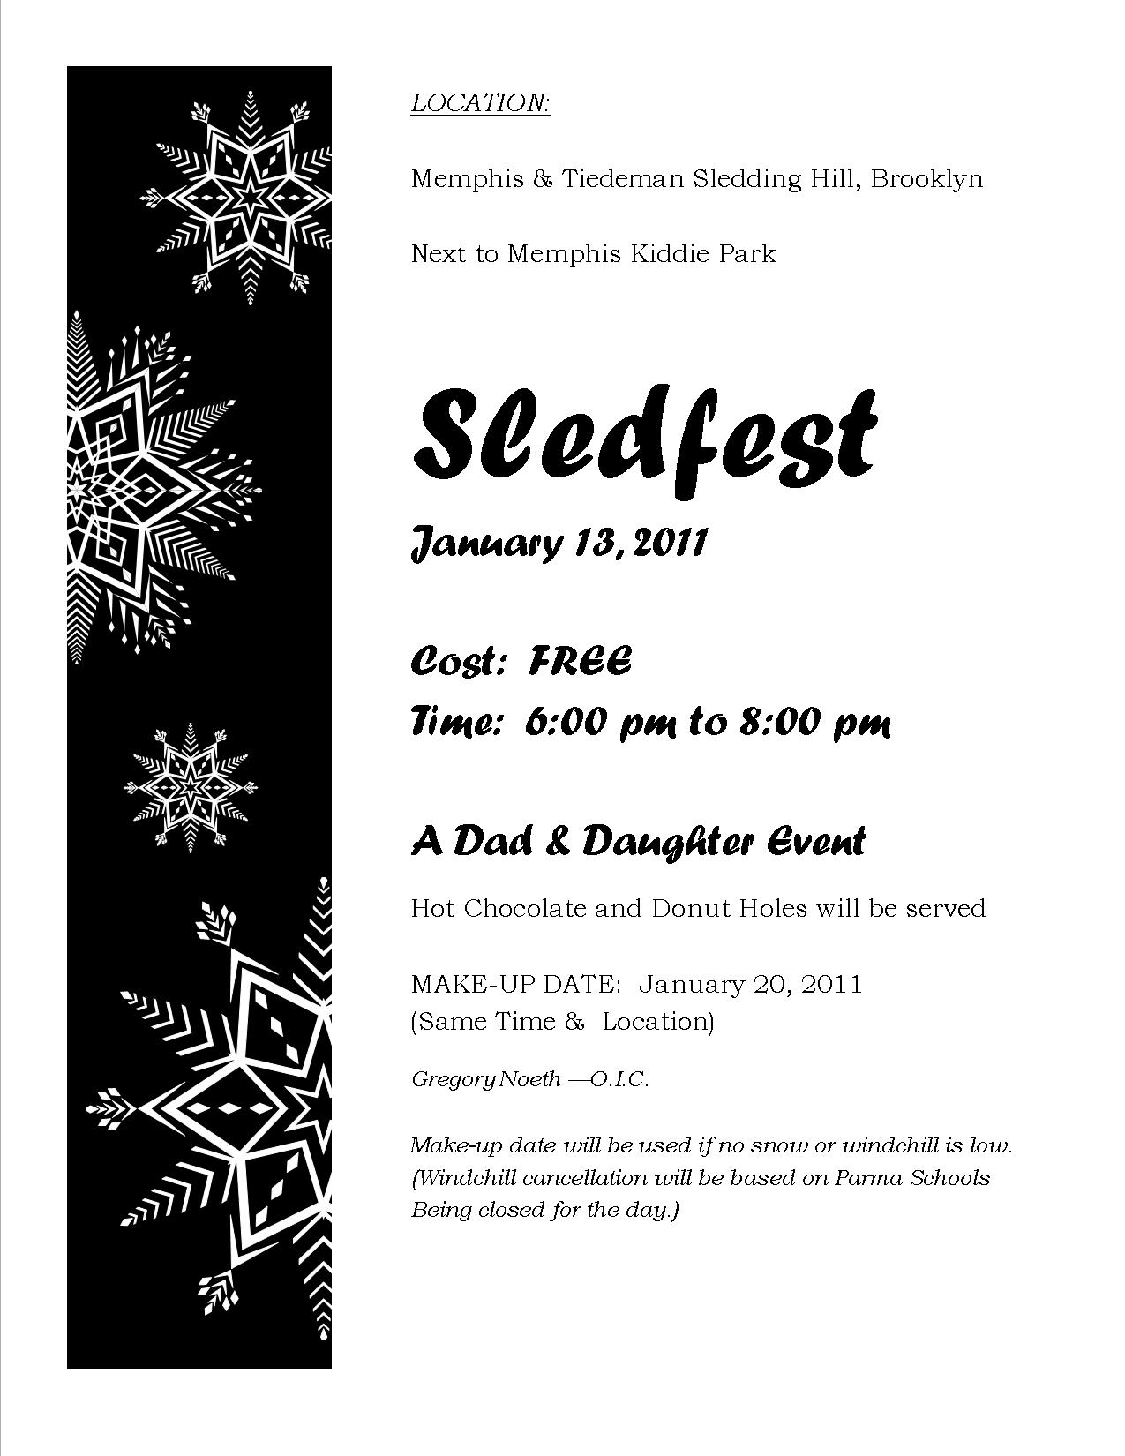**

**Mike Arraj and Family Benefit**

**January 15, 2012**

**Time 1PM -5PM**

St. Elias Church Hall

8023 Memphis Ave

Cleveland, Ohio

Chicken parmesan dinner with spaghetti,

salad, rolls, beverages and Desserts

C:\Users\mark\AppData\Local\Microsoft\Windows\Temporary Internet Files\Content.IE5\WOGTQQG6\MC900048792[1].wmf

**Dine In and Carry out available**

Donation adults $20.00

Children 12 and younger $10.00

**Basket Raffles**

**Live Auction at 3:00**

\*\* Bring the whole family and show your support

for Mike's treatment and recovery \*\*

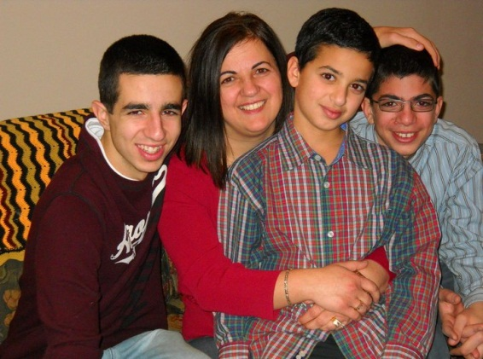 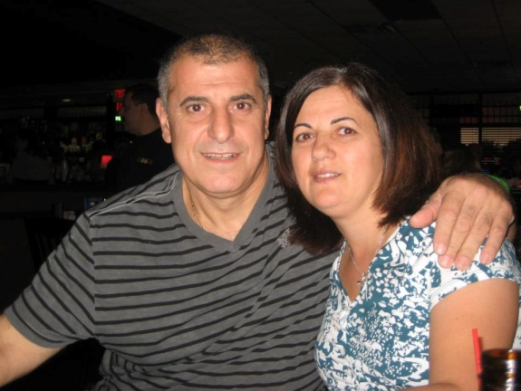

**Come join other Penguin Princesses and Emperor Penguin Dads February 17-19 at Camp Y-Noah for a weekend of winter fun. Activities include crafts, horse riding, archery, bb gun range, and council fire and (weather permitting…. SLED RIDING!!!!!!!!!)**

**Camp registration begins at the December Frontier meeting**

**Thursday, Dec 1, 2011 7:45 Busch Funeral Home**

***New Sky Dads, make sure you have your torches***

**Camping Fees: $118 Dad & Daughter**

**Extra Princess Daughter $40**

**Pony Rides $5 – Trail Rides $15**

**OIC : Mark Ruda 440-821-2418**

[**trailboss@thebigcreekfrontier.org**](mailto:trailboss@thebigcreekfrontier.org)



**Dad’s Name\_\_\_\_\_\_\_\_\_\_\_\_\_\_\_\_\_\_\_\_\_\_\_\_\_\_\_\_\_\_\_\_\_\_\_\_\_\_Territory\_\_\_\_\_\_\_\_\_\_\_\_\_\_\_\_\_\_\_**

**Daughter’s Name\_\_\_\_\_\_\_\_\_\_\_\_\_\_\_\_\_\_\_\_\_\_\_\_\_\_\_\_\_\_\_\_\_\_Outpost\_\_\_\_\_\_\_\_\_\_\_\_\_\_\_\_\_\_\_\_**

**Xtra Daughter’s Name\_\_\_\_\_\_\_\_\_\_\_\_\_\_\_\_\_\_\_\_\_\_\_\_\_\_\_\_\_\_Outpost\_\_\_\_\_\_\_\_\_\_\_\_\_\_\_\_\_\_\_\_**

*Make Checks Payable to:* **The Adventure Princesses**





MC900034104[1]

Who, What, Where ???,,,,,,,,,,,

**T-Shirt Transfer Contest  
 for Winter Campout !!**

# When: January Frontier Meeting

(Officers will be judging after the meeting)

**Date: January 5th, 2012**

**Who: All Adventure Princesses Girls**

**(Except last camp’s winner.)**

**Please bring your artwork to the meeting or send to:**

**Mike Norwalk – Asst. Running Waters Editor**

**13021 Old Mill Rd**

**Spencer, Ohio 44275 or Email:**[**asstrweditor@thebigcreekfrontier.org**](mailto:asstrweditor@thebigcreekfrontier.org)

This year we will be raffling off the lodge at Camp Y-Noah at the January Frontier Meeting on Thursday Jan 5th at Busch Funeral Home

To earn an entry, all your outpost has to do is sell Mardi Gras raffle tickets of program ads.

The rules are simple:

1. If your outpost is in the Forest, Sun or Fire Territories, you will get 1 entry per $100 worth of tickets and/or ads you turn in by Dec 31st
2. If your outpost is in the New Sky, you will get 1 entry per $75 worth of tickets and/or ads you turn in by Dec 31st
3. The more you turn in, the more entries you get. See… Simple
4. Now, why do you want to win it? That’s easy. It’s sweet. Plus it has bathrooms inside and a fireplace. Need I say more?

This drawing will also help determine horseback riding sign ups and other “lodges” if your outpost wins them.

So sell your tickets and ads fast, turn them into your scout and hope you’re the winning outpost come January

Father Daughter Dinner

St. Michael’s Woodside Banquet Hall

5025 East Mill Road Broadview Heights (by I-77 & Wallings)

MCj04159780000[1]

$40 per couple -- $20 for additional daughter

Dinner – Sun/Forest/Sky/Fire

When: Sunday, March11th, 2012  
Time: 1-5 PM

**Registration deadline 2-27-2012**

Girls wear dresses. Dads wear coat and tie. Dinner with Prime Rib for the dads,

Chicken for the Princesses, flower corsages for the girls, picture of the couple, bingo, prizes for girls, door prizes and dancing.   
  
The cost is $40 per couple, additional daughters are $20 each.   
  
Formal 5 x 7 photographs will be taken for $5.

Registration must be received by the due dates. No refunds after the due dates.

OIC: Mike Norwalk

- - - - - - - - - - - - - - - - - - - - - - - - - - - - - - - - - - - - - - - - - - - - - - - - - - - - - - - - - -

Dad: \_\_\_\_\_\_\_\_\_\_\_\_\_\_\_\_\_\_\_\_\_\_\_\_\_\_Daughter:\_\_\_\_\_\_\_\_\_\_\_\_\_\_\_\_\_\_\_\_\_\_\_\_\_

Territory: \_\_\_\_\_\_\_\_\_\_\_\_\_\_\_\_\_\_\_\_\_\_\_Outpost:\_\_\_\_\_\_\_\_\_\_\_\_\_\_\_\_\_\_\_\_\_\_\_\_\_\_

$ Enclosed: \_\_\_\_\_\_\_\_ Phone: \_\_\_\_\_\_\_\_\_\_\_\_\_\_\_\_\_\_\_\_\_\_\_\_\_\_\_

E-mail:\_\_\_\_\_\_\_\_\_\_\_\_\_\_\_\_\_\_\_\_\_\_\_\_\_\_\_\_

***Make checks payable to***: Ridgewood Adventure Princesses

**** 

Sunday March 25th

|  |  |  |
| --- | --- | --- |
| Bowling I – Sky and Fire  Registration: 11:30 A.M.  **Off Lanes 2:30 PM SHARP!** | | Bowling II – Sun and Forest  Registration: 2:30 PM  **Off Lanes 5:30 PM SHARP!** |
| **Yorktown Lanes 6218 Pearl Road (440) 886-5300** | | |
| **Includes: Bowling, Shoe Rental, DJ, Pizza, Hot Dog, Chips and Pop**  **Tour of the Pinsetters and Prizes !** | | |
| **LAST DAY to REGISTER for lowest price: March 16th 2012-No registrations after March 23rd** | | |
|  |  | |
| **Bumpers YES NO** | **No Trophies awarded for Bumpers** | |
| **Princess Name:**  **Outpost:**  **Territory:**  **Circle Bowling # 1 or # 2** | **Number Attending\_\_\_\_\_ X $6.50 =\_\_\_\_\_\_**  **After March 16th – March 23rd**  **Number Attending\_\_\_\_\_ X $10.00 =\_\_\_\_\_\_** | |
|  |  | |
| **Bumpers YES NO** | **No Trophies awarded for Bumpers** | |
| **Princess Name:**  **Outpost:**  **Territory:**  **Circle Bowling # 1 or # 2** | **Send Cash or Check payable to:**  **Ridgewood YMCA Adventure Princesses**  **Doug Payne**  **9749 Silverleaf Dr.**  **North Royalton, Ohio 44133** | |
| **Dad's Name:** | **Phone:** | |
| **OIC: Doug Payne (440) 230-2958** |  | |

**Dads who have daughters bowling in the 1st and 2nd half must pay twice. If all daughters are bowling in one half then dad pays once.**

**See all the photos taken throughout the year at our Shutterfly account.**

The latest additions are from the

North Royalton Christmas Parade.

The password is “adventure”

Follow the link below.

[**http://thebigcreekfrontier2.shutterfly.com**](http://thebigcreekfrontier2.shutterfly.com)



Overnighter

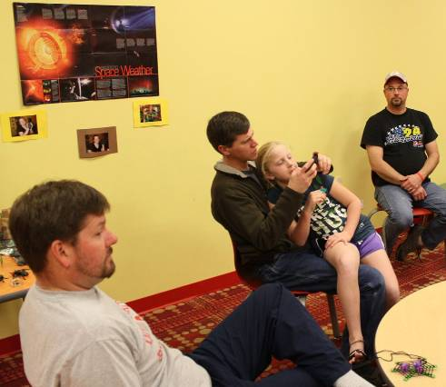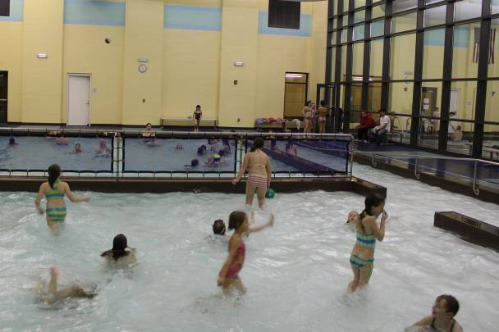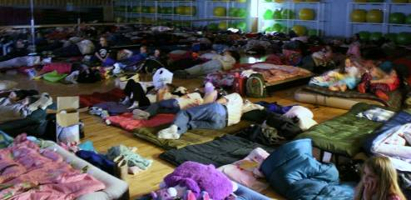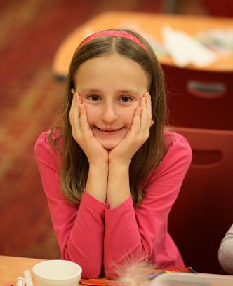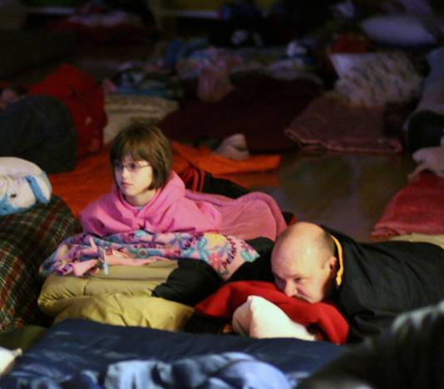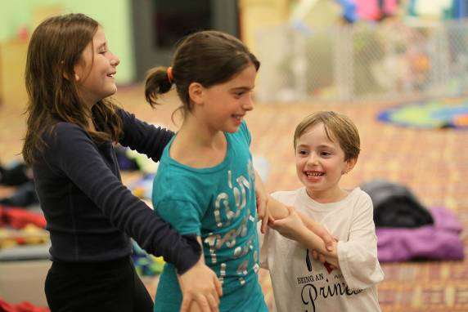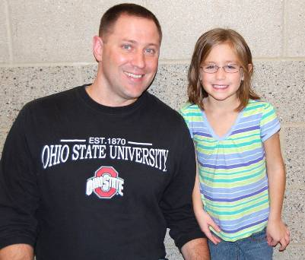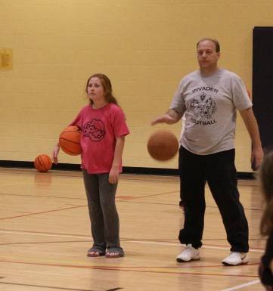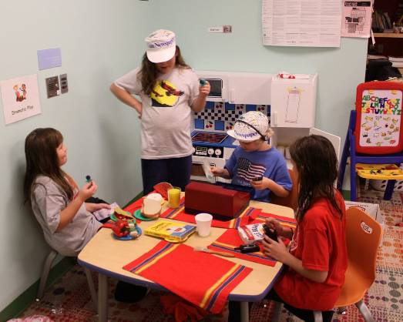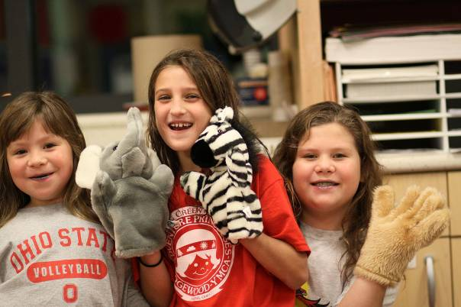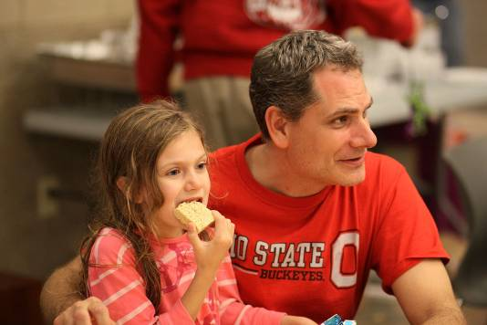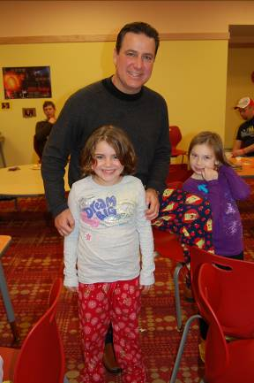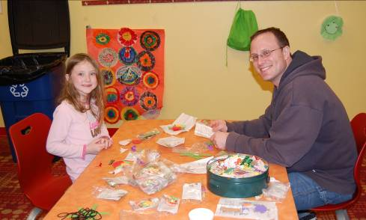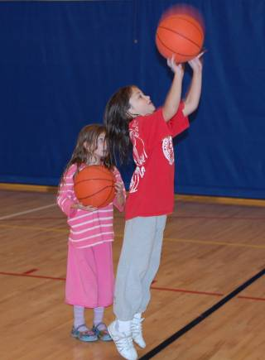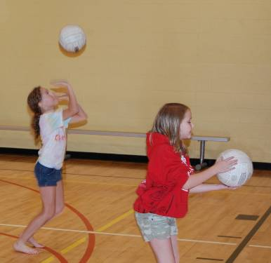

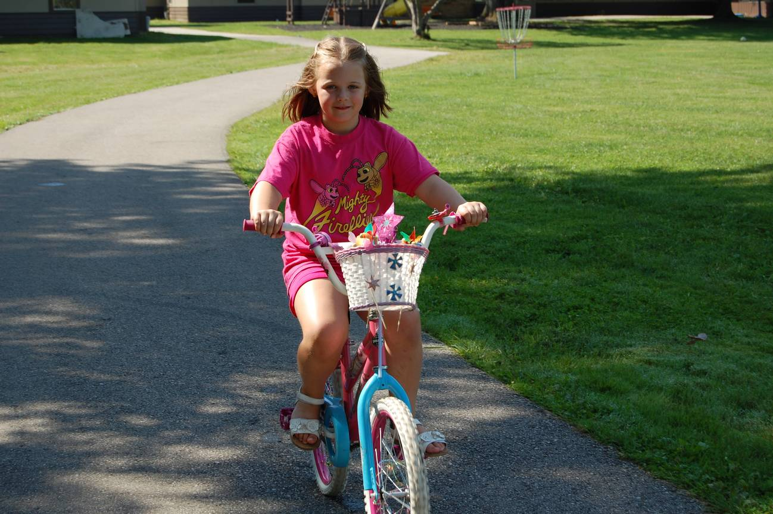

# Family Skate

# DSC_0147

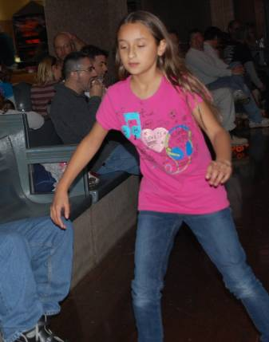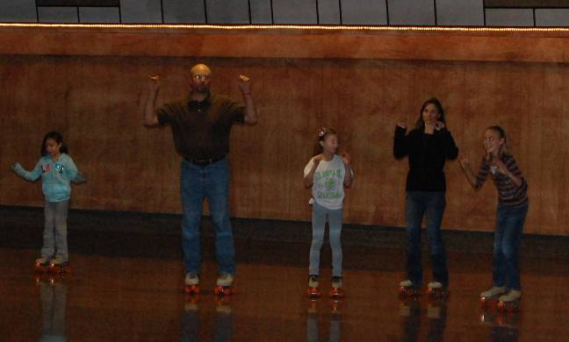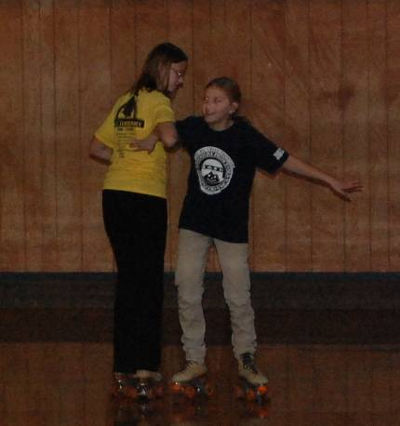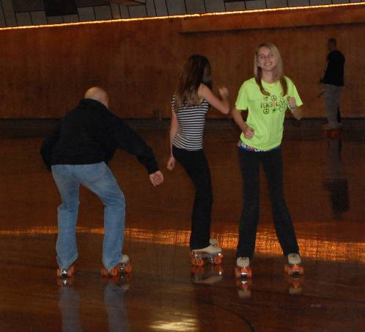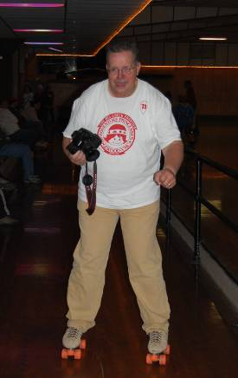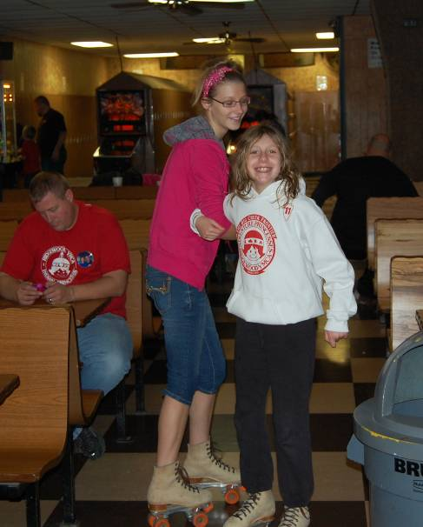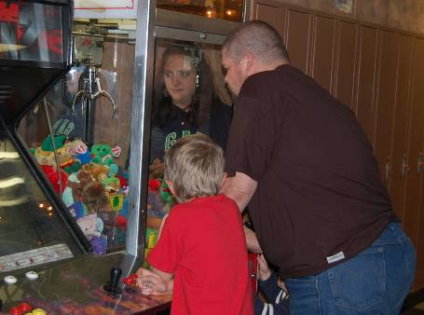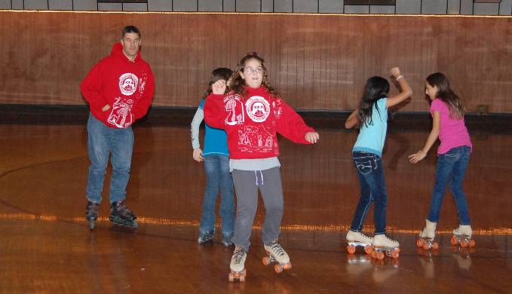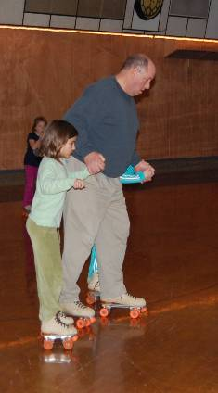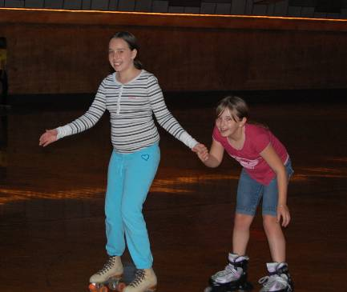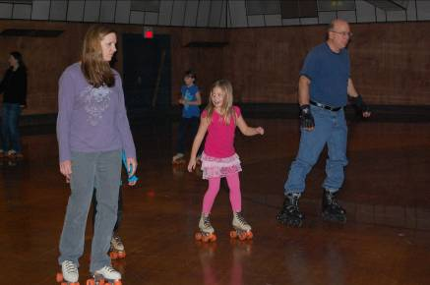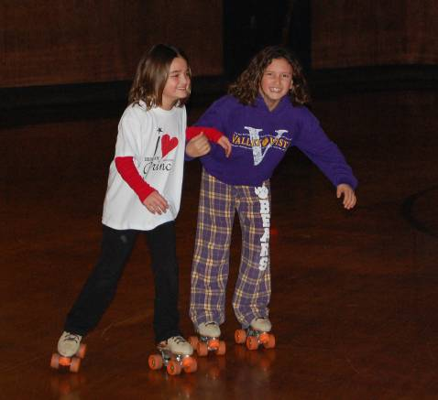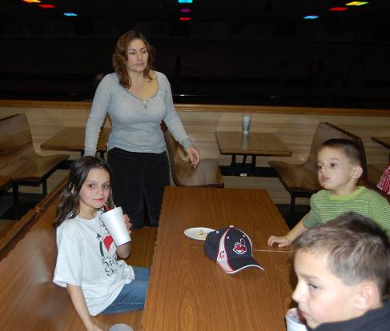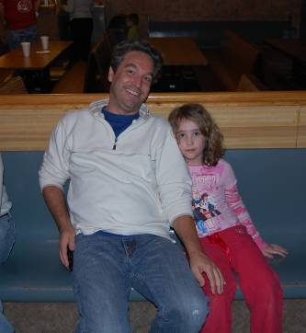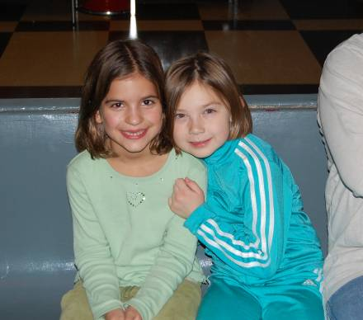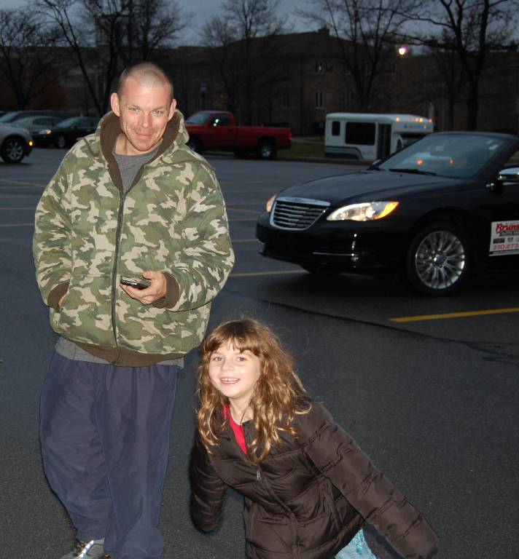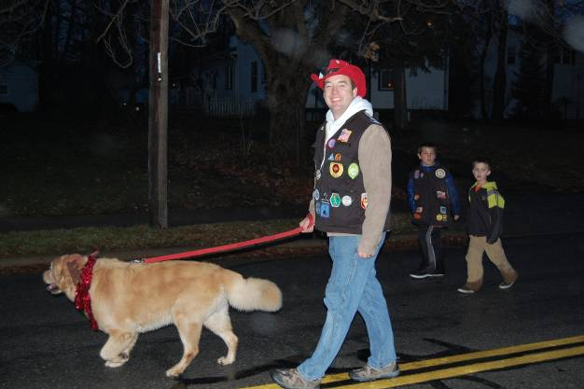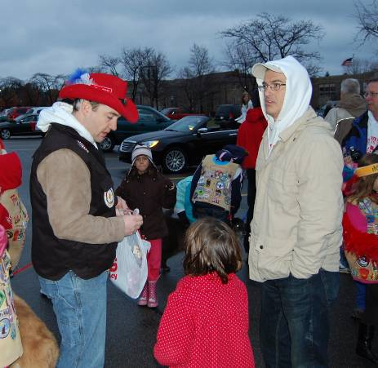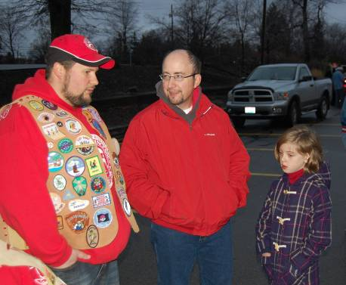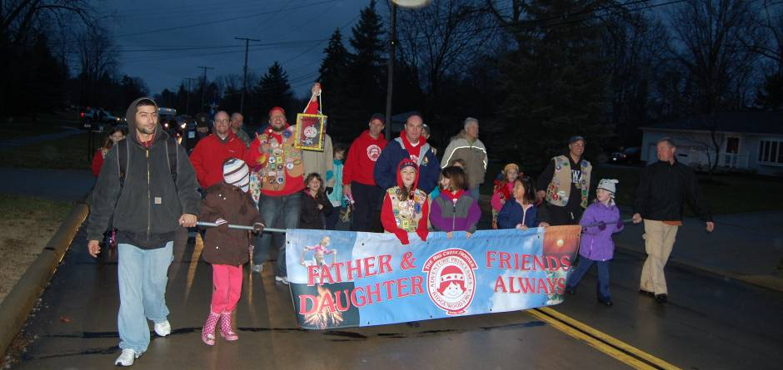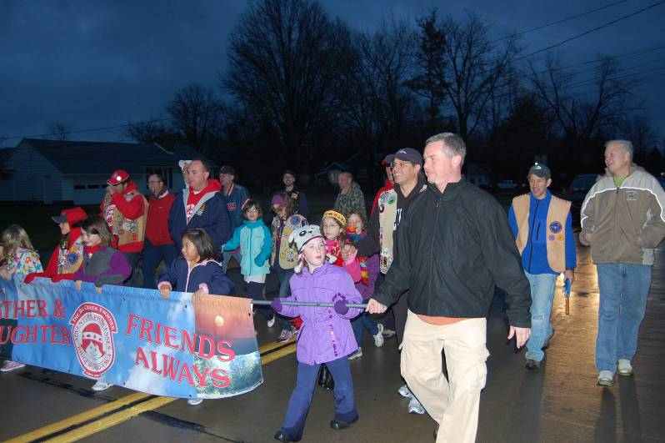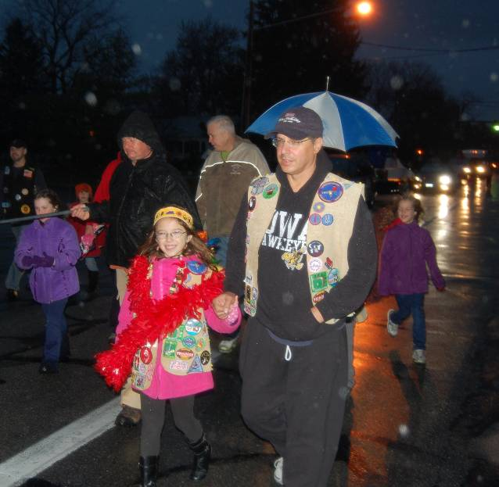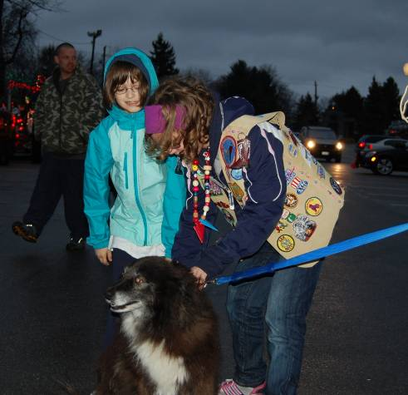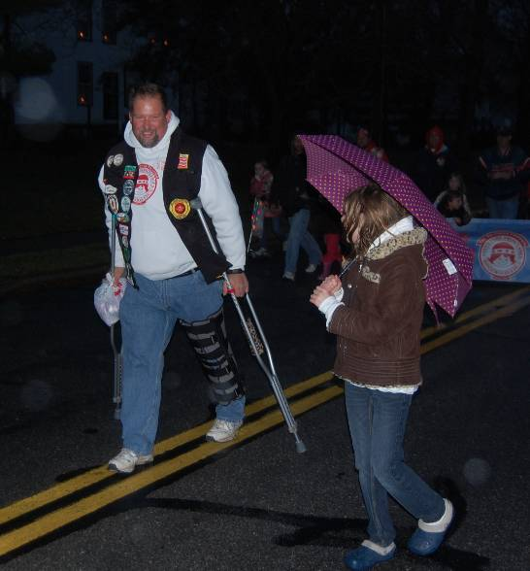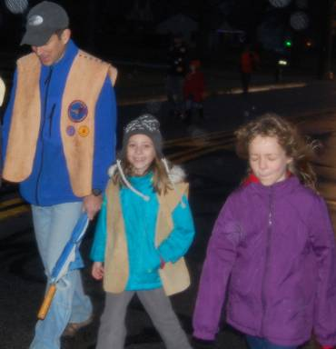

**North Royalton Christmas Parade**

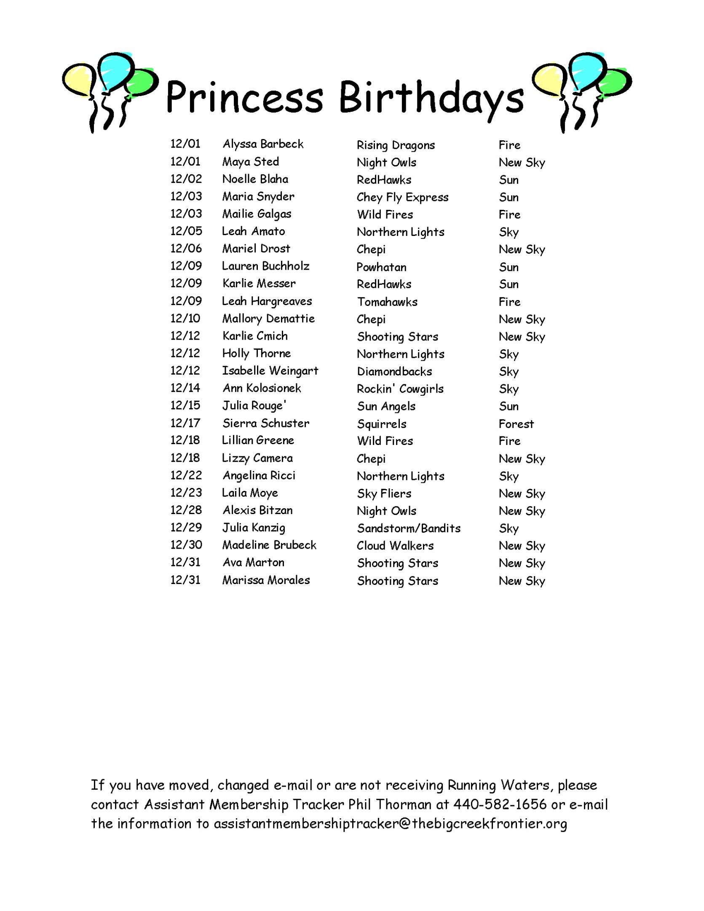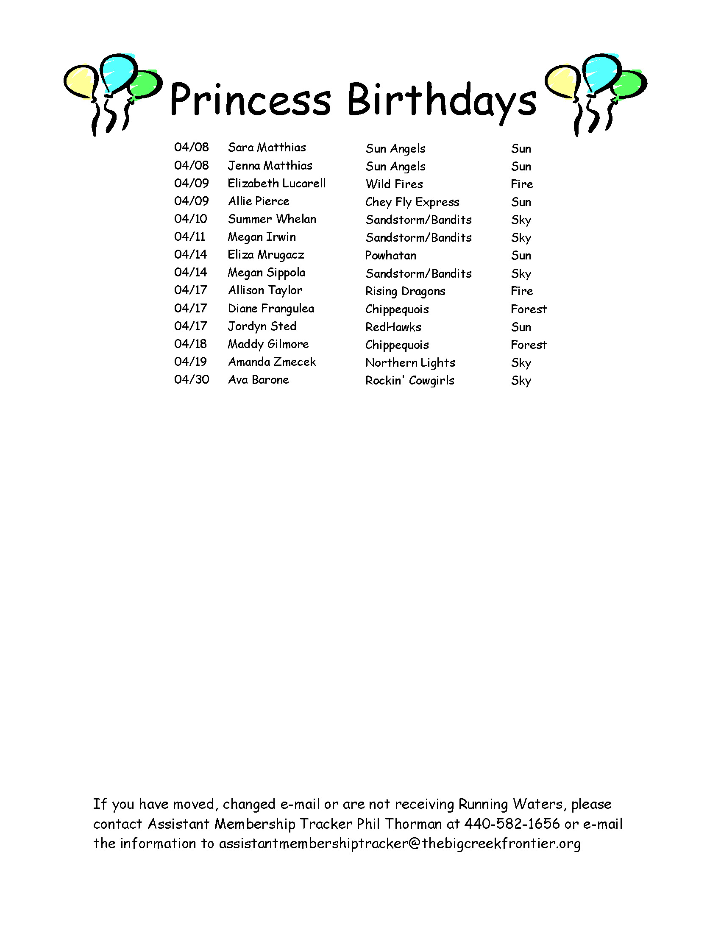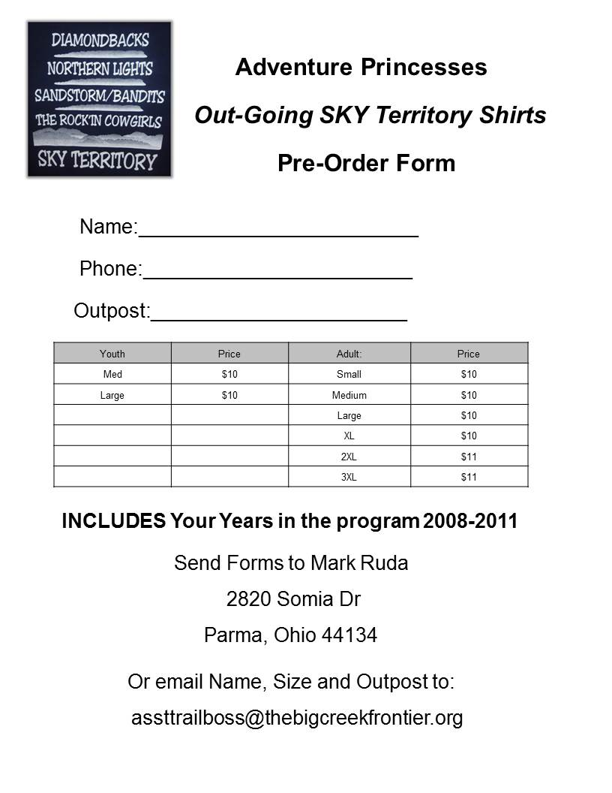

**The Running Waters is available at the Adventure Princesses’ website:**

[**http://www.thebigcreekfrontier.org**](http://www.thebigcreekfrontier.org)

**Click on Member Login and then select Running Waters**

**December 2011**

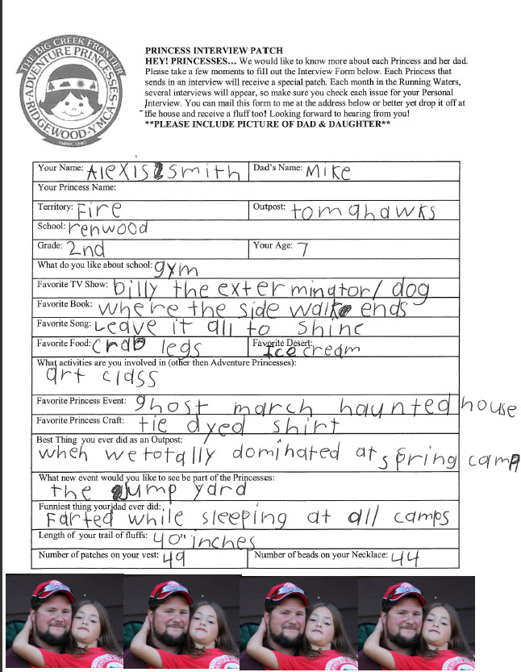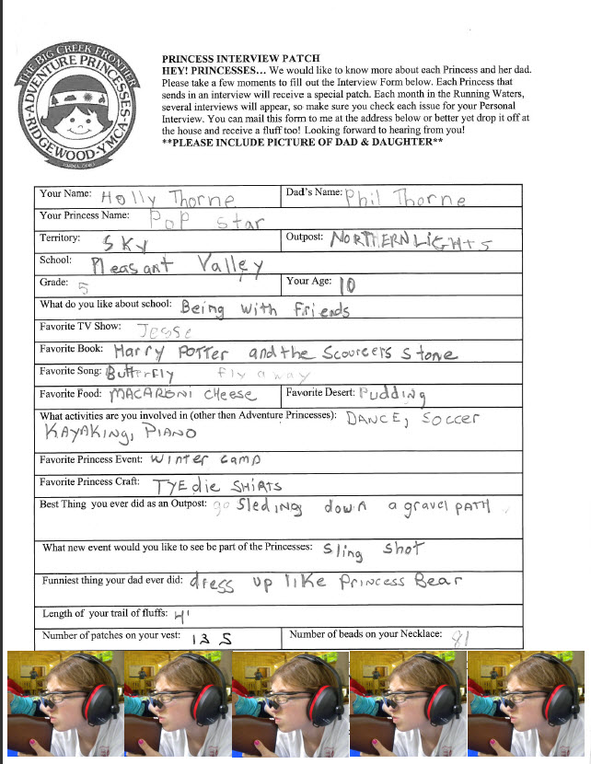



**PRINCESS INTERVIEW PATCH**

**HEY! PRINCESSES…** We would like to know more about each Princess and her dad. Please take a few moments to fill out the Interview Form below. Each Princess that sends in an interview will receive a special patch. Each month in the Running Waters, several interviews will appear, so make sure you check each issue for your Personal Interview. You can mail this form to me at the address below or better yet drop it off at the house and receive a fluff too! Looking forward to hearing from you!

\*\***PLEASE INCLUDE PICTURE OF DAD & DAUGHTER\*\***

|  |  |
| --- | --- |
| Your Name: | Dad’s Name: |
| Your Princess Name: | |
| Territory: | Outpost: |
| School: | |
| Grade: | Your Age: |
| What do you like about school: | |
| Favorite TV Show: | |
| Favorite Book: | |
| Favorite Song: | |
| Favorite Food: | Favorite Desert: |
| What activities are you involved in (other then Adventure Princesses): | |
| Favorite Princess Event: | |
| Favorite Princess Craft: | |
| Best Thing you ever did as an Outpost: | |
| What new event would you like to see be part of the Princesses: | |
| Funniest thing your dad ever did: | |
| Length of your trail of fluffs: | |
| Number of patches on your vest: | Number of beads on your Necklace: |

**REMEMBER TO INCLUDE A PICTURE OF YOU AND YOUR DAD.**

**SEND INTERVIEW TO**

**Todd Althouse**

**8077 Thornhurst Dr.**

**North Royalton, OH 44133**

send it digitally to asstrweditor@thebigcreekfrontier.org

|  |  |  |  |  |
| --- | --- | --- | --- | --- |
| ***OFFICER:*** | ***NAME:*** | ***FLUFF  COLOR:*** | ***REGULAR  RAID:*** | ***MIDNIGHT***  ***RAID:*** |
| 1. Trail Boss | Greg Noeth | Multi |  |  |
| 2. Asst. Trail Boss | Mark Ruda | Multi |  |  |
| 3. Elder | Bob Tupa | White |  |  |
| 4. Fire Maker | Pat Perhacs | Black |  |  |
| 5. Treasurer Keeper | Doug Payne | Gold |  |  |
| 6. Tally Keeper | Scott Mordaunt | Orange |  |  |
| 7. Awards Maker | Rob Ezinksi | Pink |  |  |
| 8. Running Waters Editor | Todd Althouse | Lt. Orange |  |  |
| 9. Asst. RW Editor | Mike Norwalk | Rust |  |  |
| 10. Legend Maker | Robert Thrasher | Lt. Pink |  |  |
| 11. Asst. Legend Maker | August Tischer | Aqua |  |  |
| 12. Membership Tracker | Jorge Perez | Teal |  |  |
| 13. Asst. Membership Tracker | Phil Thorman | Brown |  |  |
| 14. Outfitter | Mark Nelson | Purple |  |  |
| 15. Storyteller | Roger Bundy | Dark Pink |  |  |
| 16. Sky Territory Scout | Tim Organiscak | Royal Blue |  |  |
| 17. Forest Territory Scout | Rick Buzinski | Green |  |  |
| 18. Sun Territory Scout | Scott Smith | Yellow |  |  |
| 19. Fire Territory Scout | Rick DiCola | Red |  |  |

***FLUFF RAIDER’S LOG: 2011***

There will be a patch given to Princesses that Fluff Raid the officers at their homes. The first part of this 2-part patch will be awarded to any Princess who "raids" 14 officers at their home. The second part is for Princesses who "raid" 5 officers after midnight. Use this Fluff Raiders Log to collect signatures from the officers. When you get the 14 regular raids and/or 5 midnight raids, then "Raid" the Awards Maker for the patch(es).

**Christmas Tree Crossword**

**ACROSS**

2. A Christmas Color.   
4. December 25th   
5. "\_\_\_\_\_ roasting on an open fire"...   
6. He had visits from the Ghost of Christmas Past, Present & Future.   
7. Spicy cookie used to make little houses & people, all covered with frosting and candies.   
9. Striped candy   
12. Ebenezer Scrooge said "Bah, \_\_\_\_!"   
14. Creamy holiday drink.

**DOWN**

1. An evergreen you decorate with lights and tinsel.   
3. He 'stole' Christmas   
6. Jolly fat man in a red suit.   
8. A fellow made of snow.   
10. Santa's helpers.   
13. The finishing touch on presents.



**ELDER Bob Tupa**

# 



**Doug Buczak**

**Phone (440) 842-5200**

**Email:** [dbuczak@clevelandy.org](mailto:dbuczak@clevelandy.org)

|  |  |  |  |  |  |  |  |  |
| --- | --- | --- | --- | --- | --- | --- | --- | --- |
| Scan10005 | December | | | | | | | 2011 |
| Sunday | | **Monday** | **Tuesday** | **Wednesday** | **Thursday** | **Friday** | **Saturday** | |
|  | |  |  |  | 1  **Frontier Meeting: 7:45pm @ Busch Funeral Home** | 2  Y Open Swim 8-9:30 | 3 | |
| 4 | | 5 | 6 | 7 | 8 | 9  Y Open Swim 8-9:30 | 10 | |
| 11  Christmas Party | | 12 | 13 | 14 | 15 | 16  Festival of Fluffs  Y Open Swim 8-9:30 | 17 | |
| 18 | | 19 | 20 | 21 | 22  **Officers' Meeting: at 7:00pm @ Busch Funeral Home** | 23  Y Open Swim 8-9:30 | 24 | |
| C:\Users\talthouse.BEACONSOFTCO.000\AppData\Local\Microsoft\Windows\Temporary Internet Files\Content.IE5\70SLH39D\MC900432449[1].wmf25  Merry Christmas! | | 26 | 27 | 28 | 29 | 30 | 31 | |
|  | |  |  |  |  |  |  | |



***YMCA of Greater Cleveland***

***Ridgewood YMCA***

***6840 Ridge Rd.***

***Parma, OH 44129***

***Adventure Princesses***

***The Big Creek Frontier***

***To the Cabin of:***

|  |  |  |  |  |
| --- | --- | --- | --- | --- |
| **2011 Frontier Officers** | **Name** | **Daughter** | **Phone** | **Address and Email** |
| Trail Boss | Greg Noeth | Greta, Marlena | 216-398-3428 | 4672 Hilland Dr,Cleveland Ohio 44109  [trailboss@thebigcreekfrontier.org](mailto:trailboss@thebigcreekfrontier.org) |
| Assistant Trail Boss | Mark Ruda | Ashley | 440-821-2418 | 2820 Somia Drive, Parma, OH 44134  [assttrailboss@thebigcreekfrontier.org](mailto:assttrailboss@thebigcreekfrontier.org) |
| Elder | Bob Tupa | Maddie | 440-845-9018 | 7907 Spring Garden, Parma, Ohio 44129  [elder@thebigcreekfrontier.org](mailto:elder@thebigcreekfrontier.org) |
| Fire Maker | Pat Perhacs | Katie | 216-559-0252 | 9600 Tilby Road, North Royalton, OH 44133  [Firemaker@thebigcreekfrontier.org](mailto:Firemaker@thebigcreekfrontier.org) |
| Treasure Keeper | Doug “Patches” Payne | Cassidy | 440-230-2958 | 9749 Silverleaf Dr, North Royalton,OH 44133  [treasurerkeeper@thebigcreekfrontier.org](mailto:treasurerkeeper@thebigcreekfrontier.org) |
| Tally Keeper | Scott Mordaunt | Ella | 440-237-3217 | 11569 Glen Abbey Dr. North Royalton 444133  [tallykeeper@thebigcreekfrontier.org](mailto:tallykeeper@thebigcreekfrontier.org) |
| Awards Maker | Rob Ezinski | Chiara | 440-478-5463 | 2919 Maplecrest Ave, Parma, OH 44134  [awardsmaker@thebigcreekfrontier.org](mailto:awardsmaker@thebigcreekfrontier.org) |
| RW Editor | Todd Althouse | Katie | 440-237-6623 | 8077 Thomhurst Dr.North Royalton, 44133  [rweditor@thebigcreekfrontier.org](mailto:rweditor@thebigcreekfrontier.org) |
| Asst. RW Editor | Mike Norwalk | Kaylee and Lindsay | 330-648-7100 | 13021 Old Mill Rd, Spencer, OH 44275  [Asstrweditor@thebigcreekfrontier.org](mailto:Asstrweditor@thebigcreekfrontier.org) |
| Legend Maker | Robert Thrasher | Shannon | 440-843-6418 | 11100 Westborough Rd, Parma, OH 44130  [legendmaker@thebigcreekfrontier.org](mailto:legendmaker@thebigcreekfrontier.org) |
| Asst. Legend Maker | August Tischer | Blythe | 440-941-6747 | 7220 Lakeview Dr, Parma, OH 44129  [asstlegendmaker@thebigcreekfrontier.org](mailto:asstlegendmaker@thebigcreekfrontier.org) |
| Membership Tracker | Jorge Perez | Lillieanna | 440-364-3415 | 6554 Alyesworth, Parma Heights, OH 44130  [membershiptracker@thebigcreekfrontier.org](mailto:membershiptracker@thebigcreekfrontier.org) |
| Asst. Membership Tracker | Phil Thorman | Tori | 440-582-1656 | 5661 Goodman Dr, North Royalton, OH 44133  [asstmembershiptracker@thebigcreekfrontier.org](file:///C:\My%20Documents\AdventurePrincesses\RW2011\APR\asstmembershiptracker@thebigcreekfrontier.org) |
| Outfitter | Mark Nelson | Olivia /Alaina | 440-343-0269 | 8395 Craigleigh Dr.,Parma, OH 44129  [outfitter@thebigcreekfrontier.org](mailto:outfitter@thebigcreekfrontier.org) |
| Storyteller | Roger Bundy | Grace | 216-375-3679 | 4544 South Hills Dr., Cleveland, OH 44109  [storyteller@thebigcreekfrontier.org](file:///C:\My%20Documents\AdventurePrincesses\RW2011\APR\storyteller@thebigcreekfrontier.org) |
| Sky Territory Scout | Tim Organiscak | Hailey | 440-582-7489 | 8960 Tiffany Dr.North Royalton, 44133  [skyscout@thebigcreekfrontier.org](mailto:skyscout@thebigcreekfrontier.org) |
| Sun Territory  Scout | Scott Smith | Madison | 440-888-1274 | 1699 Jacqueline Dr., Parma, OH 44134  [sunscout@thebigcreekfrontier.org](mailto:sunscout@thebigcreekfrontier.org) |
| Forest Territory Scout | Rick “Elbows” Buzinski | Amelia | 216-543-9201 | 6847 Greenleaf Ave,Parma Hts, OH 44130  [forestscout@thebigcreekfrontier.org](mailto:forestscout@thebigcreekfrontier.org) |
| Fire Territory Scout | Mark Ruda | Ashley | 440-821-2418 | 2820 Somia Drive, Parma, OH 44134  [assttrailboss@thebigcreekfrontier.org](mailto:assttrailboss@thebigcreekfrontier.org) |